== GHANA EV GRID INTEGRATION ANALYSIS (ENHANCED COMPLETE) ===

Optimizing Electric Vehicle Integration in Ghana's Power Grid

A Comprehensive Techno-Economic Analysis with Seasonal & Reserve Analysis

📊 Loading Ghana Hourly Electricity Demand Data...

✅ Data loaded successfully!

📈 Dataset shape: (8784, 4)

📅 Date range: 2024-01-01 00:00:00 to 2024-12-31 23:00:00

🔧 Enhanced features created successfully!

================================================================================

🚀 EXECUTING COMPREHENSIVE EV GRID INTEGRATION ANALYSIS

================================================================================

🌦️ Phase 1: Seasonal Analysis

🌦️ ANALYZING SEASONAL EV IMPACT VARIATIONS...

🌧️ July Peak EV Load: 413.6 MW

❄️ January Peak EV Load: 387.8 MW

📈 Seasonal EV Load Increase: 6.7%

🌡️ Total Load Seasonal Increase: 0.0%

🚨 IDENTIFYING SEASONAL SUPER-PEAK PERIODS...

⚡ Super-Peak Threshold: 2796.3 MW

🎯 Number of Super-Peak Periods: 88

🔋 EV Amplification Factor during Super-Peaks: 2.47x

☀️ Summer Super-Peak Concentration: 28.4%

🌡️ Most Critical Month: May (11 occurrences)

📅 Phase 2: Weekend vs Weekday Analysis

📅 ANALYZING WEEKEND VS WEEKDAY EV BEHAVIOR...

🏢 Weekday EV Peak: Hour 7 (342.3 MW)

🏠 Weekend EV Peak: Hour 7 (347.7 MW)

⏰ Peak Hour Shift: 0 hours

📊 Weekend/Weekday Ratio: 1.02

⚡ ANALYZING WEEKEND VS WEEKDAY GRID STRESS PATTERNS...

📈 Weekend Average Stress: 0.474

📈 Weekday Average Stress: 0.462

🚨 Weekend Critical Periods: 250

🚨 Weekday Critical Periods: 629

🔋 Phase 3: Grid Reserve Margin Analysis

🔋 CALCULATING GRID RESERVE MARGINS (Capacity: 5000 MW)...

⚠️ Minimum Base Reserve Margin: 96.9%

🚨 Minimum EV Reserve Margin: 73.8%

📉 Reserve Degradation: 23.1%

🔴 Critical Periods (Base): 0

🔴 Critical Periods (With EV): 0

⚡ Load Shedding Required: 0 periods

🚨 IDENTIFYING CAPACITY LIMIT PERIODS...

✅ No capacity overload detected

⚠️ High utilization periods: 0

📊 Phase 4: Creating Enhanced Visualizations

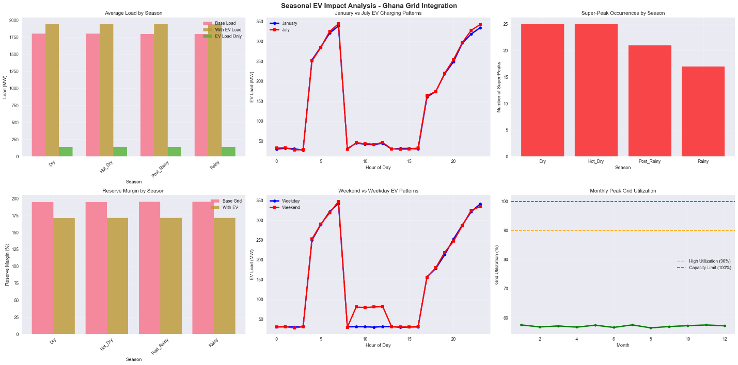

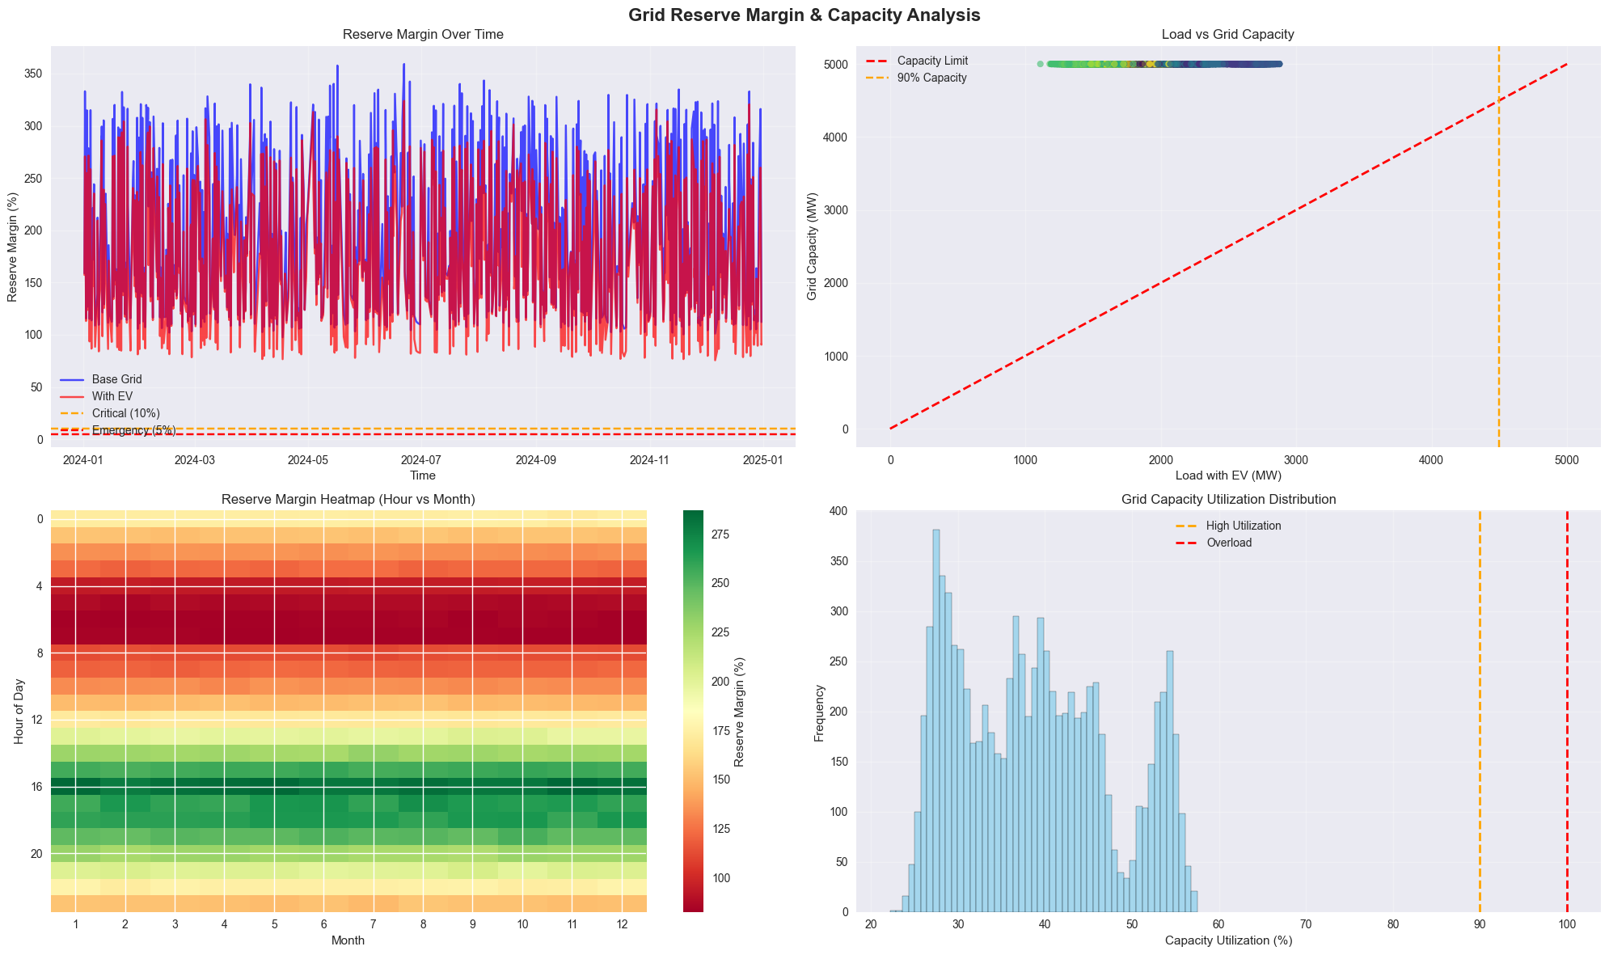

📊 Creating Interactive Seasonal Analysis Dashboard...

0102010020030001020100200300DryHot_DryPost_RainyRainy051015202501020100200300DryHot_DryPost_RainyRainy05010015020051060708090100

Dry SeasonHot_Dry SeasonRainy SeasonPost_Rainy SeasonJanuary (Dry)July (Rainy)Super-PeaksWeekdayWeekendBase Grid ReserveWith EV ReservePeak UtilizationGhana EV Grid Integration - Seasonal & Behavioral Analysis DashboardHour of DayHour of DaySeasonHour of DaySeasonMonthEV Load (MW)EV Load (MW)Super-Peak CountEV Load (MW)Reserve Margin (%)Utilization (%)Seasonal EV Load PatternsJan vs Jul Hourly ComparisonSuper-Peak Analysis by SeasonWeekend vs Weekday PatternsReserve Margin by SeasonCapacity Utilization Trends

================================================================================

🎯 GENERATING CRITICAL INSIGHTS AND RECOMMENDATIONS

================================================================================

🌦️ SEASONAL INSIGHTS & RECOMMENDATIONS

============================================================

🔥 SEASONAL PEAK AMPLIFICATION:

• EV demand increases 6.7% from January to July

• July peak EV load: 413.6 MW

• January peak EV load: 387.8 MW

⚡ SUPER-PEAK CONCENTRATION:

• 28.4% of super-peaks occur in hot season

• EV amplification factor: 2.47x

📅 BEHAVIORAL INSIGHTS & RECOMMENDATIONS

============================================================

🕐 CHARGING BEHAVIOR PATTERNS:

• Peak hour shifts 0 hours on weekends

• Weekend peak is 1.02x weekday peak

🔋 GRID CAPACITY INSIGHTS & RECOMMENDATIONS

============================================================

📊 RESERVE MARGIN ANALYSIS:

• Minimum reserve margin with EV: 73.8%

• Reserve degradation due to EV: 23.1%

🎯 COMPREHENSIVE STRATEGIC RECOMMENDATIONS

======================================================================

1️⃣ IMMEDIATE ACTIONS (0-6 months):

• Deploy smart charging infrastructure with grid awareness

• Implement time-of-use tariffs for EV charging

• Establish emergency load shedding protocols for EV charging

• Install real-time grid monitoring systems

2️⃣ SHORT-TERM STRATEGIES (6-18 months):

• Develop seasonal EV charging algorithms

• Deploy distributed energy storage systems

• Implement vehicle-to-grid (V2G) pilot programs

• Create weekend-specific charging incentives

3️⃣ MEDIUM-TERM PLANNING (1-3 years):

• Expand grid capacity for identified bottlenecks

• Deploy community-scale energy storage

• Implement comprehensive demand response programs

• Develop EV-solar integration strategies

4️⃣ LONG-TERM VISION (3-5 years):

• Achieve 100% renewable-powered EV charging

• Implement fully automated grid management

• Deploy nationwide V2G infrastructure

• Establish EV charging as grid stabilization service

💰 ECONOMIC IMPACT SUMMARY:

• Estimated daily EV energy consumption: 1245579 MWh

• Estimated daily charging revenue: $149469

• Annual EV charging revenue potential: $54556364

📋 KEY PERFORMANCE INDICATORS TO MONITOR:

• Reserve margin maintenance above 10%

• Zero unplanned load shedding events

• EV charging cost competitiveness vs conventional vehicles

• Grid stability metrics during peak charging periods

• Customer satisfaction with charging availability

================================================================================

✅ GHANA EV GRID INTEGRATION ANALYSIS COMPLETED

📊 All visualizations, insights, and recommendations generated

🎯 Ready for strategic implementation planning

================================================================================

[ ]: